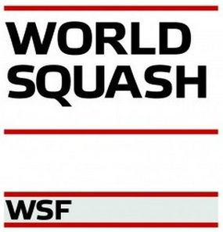

Ardic Egyptian Junior Open 2020
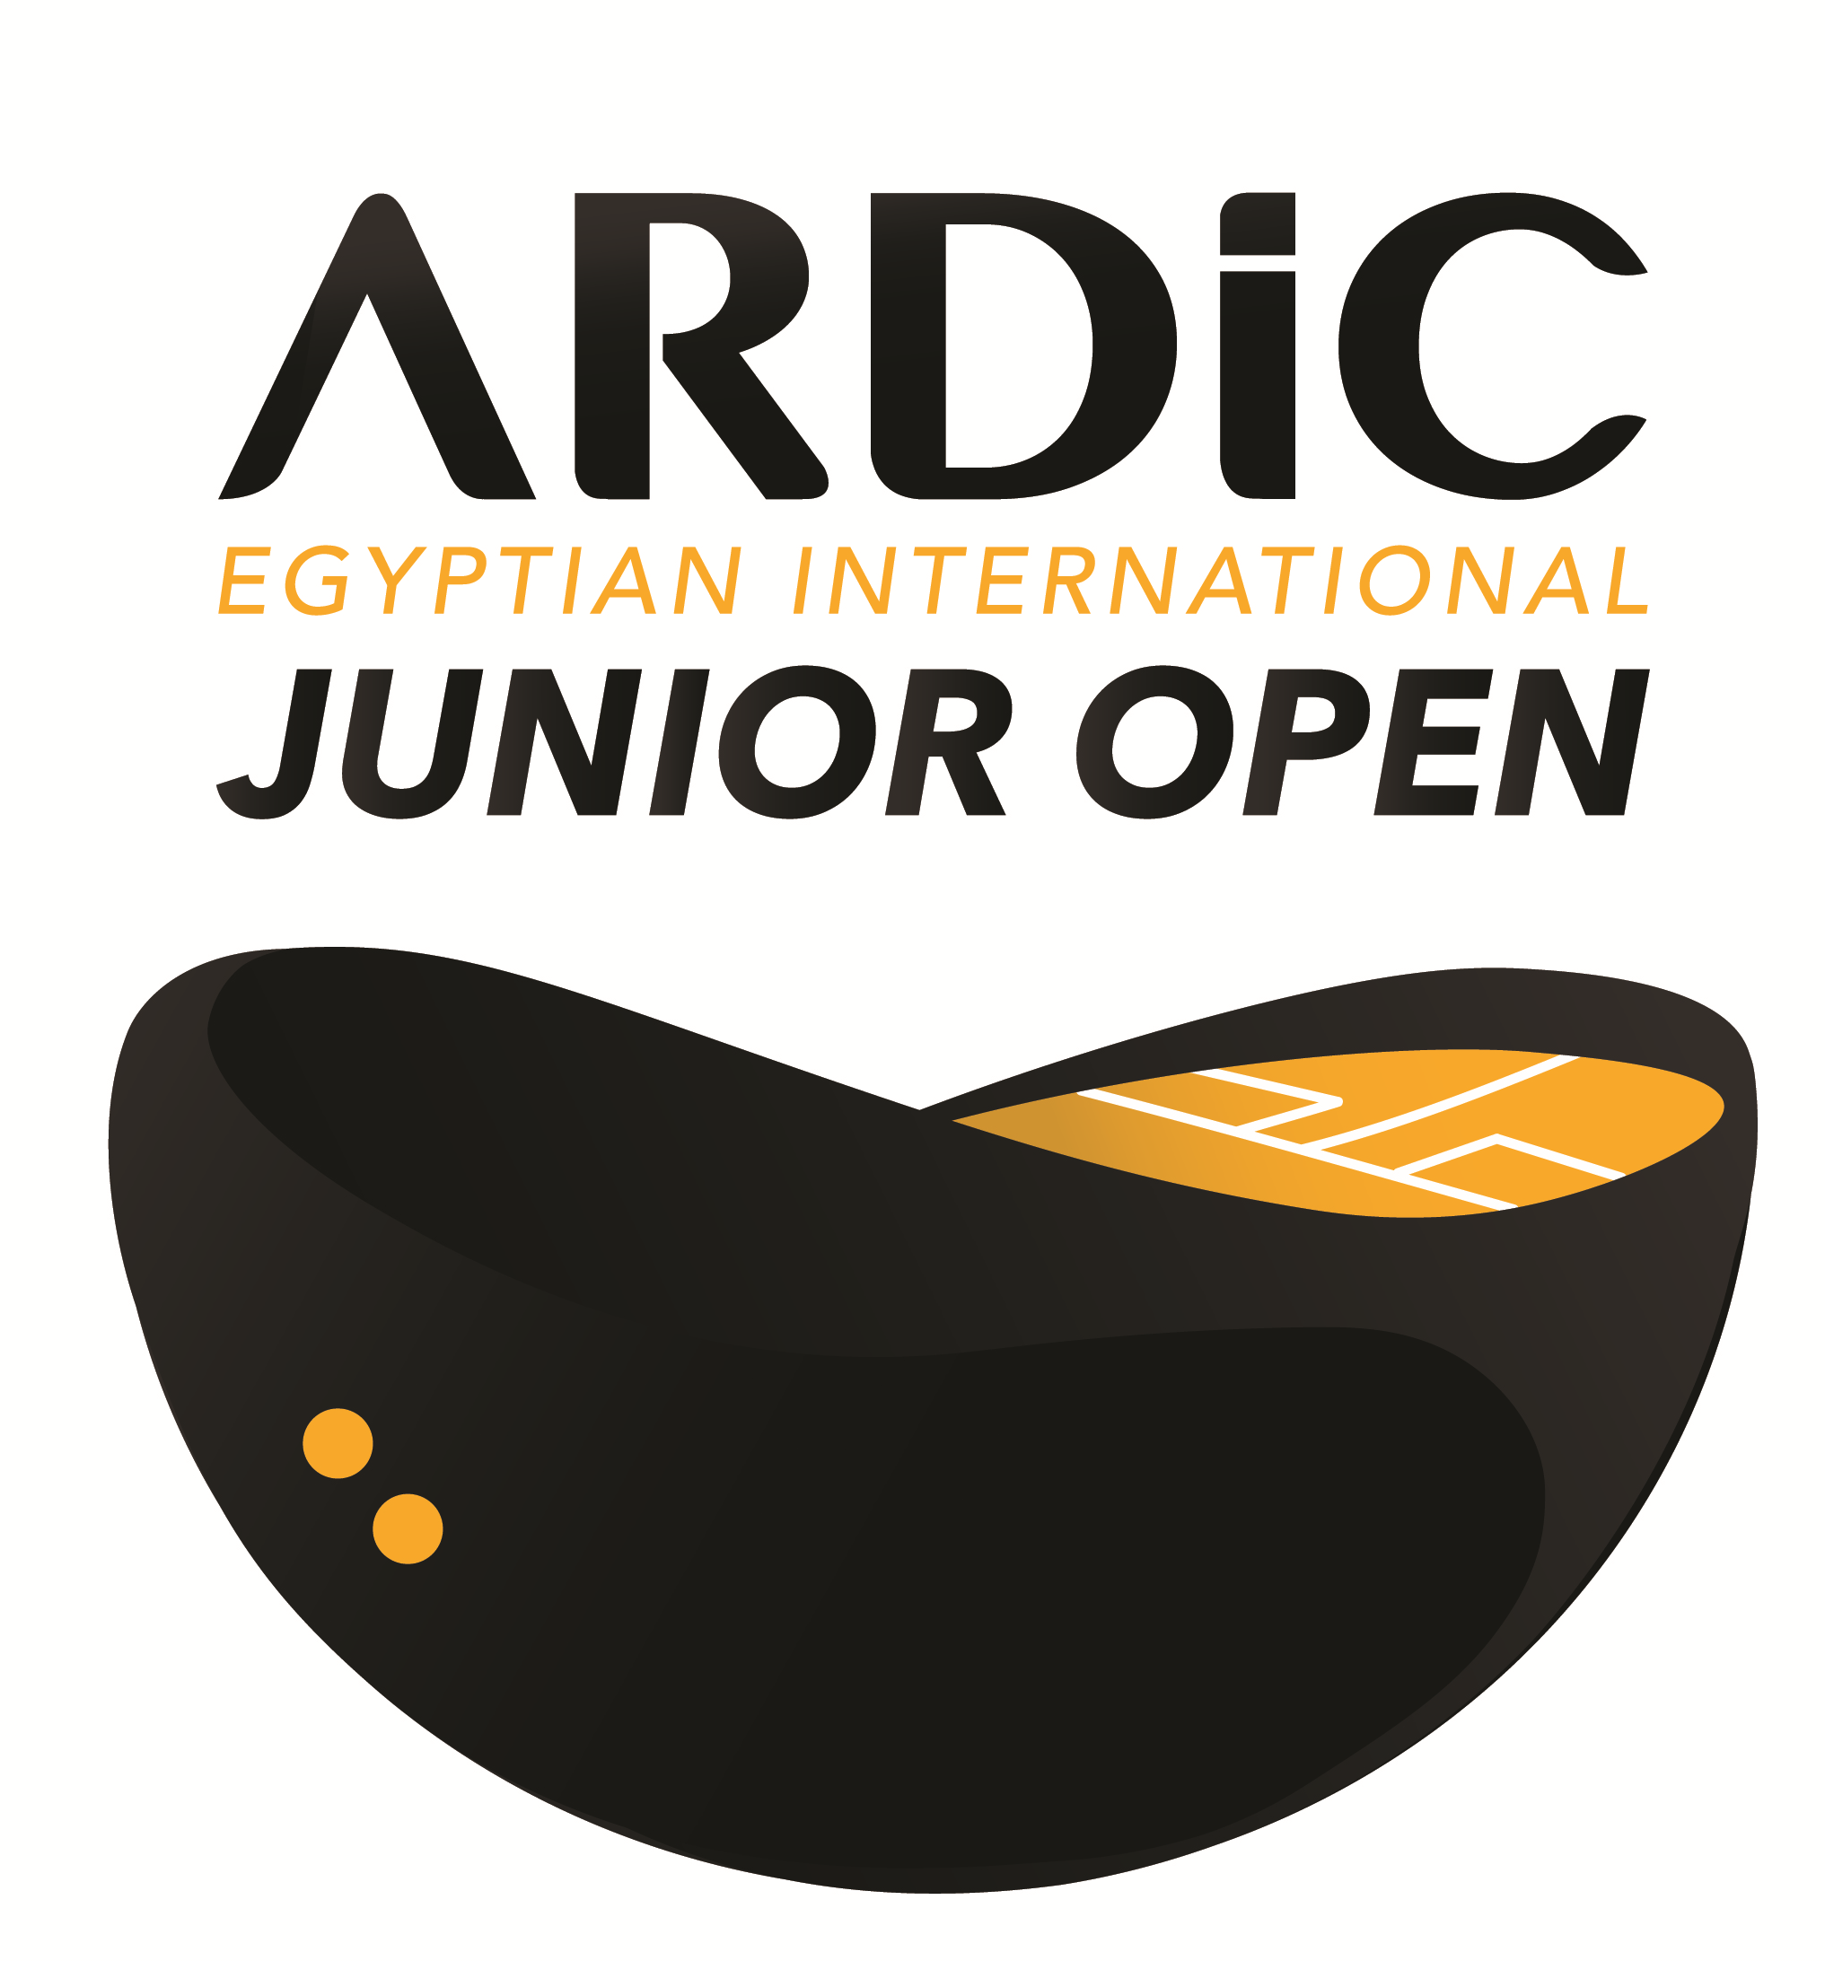
Hosted by Powered by

DATE
Saturday 18th July – Tuesday 21st July 2020.
The tournament will commence on Saturday 18th July.
The Final will be on Tuesday 21st July 2020.

VENUE

Blackball Sporting Club

90th street, behind Concord plaza, 5th settlement, New Cairo, Egypt
www.blackballsportingclub.com
Telephone: 002-01000056118

CATEGORIES

Boys & Girls U11, U13, U15, U17, U19
The ARDIC Egyptian Junior Open is open to all players under the age of 11, 13, 15, 17, 19 on the 21st July 2020 (final scheduled date of the event).

Players may only enter one category.

SEEDING

The seeding will be carried out using the European Junior Ranking valid at the closing date. Any non-European players without an ESF Junior Ranking will be seeded by the Tournament Technical Director.

MATCHES & SCORING

All matches will be played as best of five games, under the rules of the WSF.
There are at least three matches guaranteed for each player (all parties certified will be played).

REFEREEING

All players will be expected to mark and referee matches plus local referee.

BALL

DUNLOP PRO

CLOSING DATE: Sunday, 21st of June 2020 00:00am
http://egyptianjunioropensquash.com/
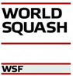

ENTRIES

All players must complete the official entry form individually and email it to:
ARDIC Egyptian Junior Open Organizations Team, safa@noletegypt.com

ENTRY & PACKAGE FEES (5 stars hotel)

PACKAGE A2 (Player): 5 Nights hotel (double room), 8 meals, entry fee & transport….. € 490
(Friday IN 17.07 – Wednesday OUT 22.07)
PACKAGE A1 (Player): 5 Nights hotel (single room), 8 meals, entry fee & transport…… € 690
(Friday IN 17.07 – Wednesday OUT 22.07)

PACKAGE B2 (Player): 6 Nights hotel (double room), 10 meals, entry fee & transport…..€ 590
(Friday IN 17.07 – Thursday OUT 23.07)
PACKAGE B1 (Player): 6 Nights hotel (single room), 10 meals, entry fee & transport….. € 790
(Friday IN 17.07 – Thursday OUT 23.07)

PACKAGE C2: 5 Nights hotel (double room), 8 meals & transport………………..€ 440
(Accompanying person) (Friday IN 17.07 – Wednesday OUT 22.07)
PACKAGE C1: 5 Nights hotel (single room), 8 meals & transport…………………€ 640
(Accompanying person) (Friday IN 17.07 – Wednesday OUT 22.07)

PACKAGE D2: 6 Nights hotel (double room), 10 meals & transport………………€ 540
(Accompanying person) (Friday IN 17.07 – Thursday OUT 23.07)
PACKAGE D1: 6 Nights hotel (single room), 10 meals & transport………………. € 740
(Accompanying person) (Friday IN 17.07 – Thursday OUT 23.07)

Entry fee: (No hotel, no transport, no meals)……………………………………€ 50
National players…………………………………………………....L.E 500

ADDITIONALS: 1 extra Night/triple room………………………………………………………€ 65
1 extra Night/double room……………………………………………………€ 85
1 extra Night/single room…………………………………….....................€ 120

Reservations can only be made by the tournament organizers.

Meals (A1, A2, C1, C2): 10 meals lunch & dinner at the club
(Friday, Saturday, Sunday, Monday, Tuesday, Wednesday)
Wednesday | Tuesday | Monday | Sunday | Saturday | Friday
Hotel/Breakfast | Hotel/Breakfast | Hotel/Breakfast | Hotel/Breakfast | Hotel/Breakfast | xxx
Lunch | Lunch | Lunch | Lunch | Lunch | xxx
xxx | Dinner | Dinner | Dinner | Dinner | Dinner

Meals (B1, B2, D1, D2): 12 meals lunch & dinner at the club
(Friday, Saturday, Sunday, Monday, Tuesday, Wednesday, Thursday)
Thursday | Wednesday | Tuesday | Monday | Sunday | Saturday | Friday
Hotel/Breakfast | Hotel/Breakfast | Hotel/Breakfast | Hotel/Breakfast | Hotel/Breakfast | Hotel/Breakfast | xxx
Lunch | Lunch | Lunch | Lunch | Lunch | Lunch | xxx
xxx | Dinner | Dinner | Dinner | Dinner | Dinner | Dinner

Entertainment: (Free of charge)
Half day for sightseen.

Transport: (Free of charge)
Airport/hotel (arrival)
Hotel/club/hotel
Hotel/airport (departure)

http://egyptianjunioropensquash.com/

The entry fee must be paid by bank transfer (net of bank charges, latest by the closing date!) to:
Bank: CIB
Account name: NO LET SQUASH AND TENNIS CLUB
Account number:
EGP : 100038311128
USD : 100038311179
EUR : 100038570824
Swift code: CIBEEGCX146
Bank address: emerald mall, 1st settlement, new Cairo, Cairo, Egypt

PL NOTICE: only players who already made payment and send transfer proof will be added to entry list.
Pl make sure you transfer entry fees and send receipt to our email safa@noletegypt.com

Please mark payment clearly for ARDIC Egyptian Junior Open 2020 and player’s/federation’s name.
In the event of a withdrawal, fees will be reimbursed as follows:

- Withdrawal before 4th of July 2019 fees will be reimbursed in full less bank charges.

- Withdrawal between 4th of July & 15th July 2019 50% of fees will be reimbursed less bank charges.
- Withdrawal after 15th July 2019 charges any reimbursement will be at the discretion of the organizer.

Questions with regards to payment please contact: safa@noletegypt.com

HOTEL

- The Westin Cairo Golf Resort & Spa
Road 90 New Cairo City, Katameya Dunes، Cairo Governorate 11835

This hotel is only 3 km (5 minutes by car) from the venue.
- Dusit Thani Lakeview Cairo
El-Tessen street, fifth settlement, Cairo, Egypt

This hotel is only 1,5 km (3 minutes by car) from the venue.

Draws
The seeding will be circulated to all players or their national associations by e-mail.
Times of first matches will be indicated for their respective players.

EYE GUARDS

Wearing of approved eye protection on court is mandatory for this event. Players will not be allowed to compete without approved eye protection. Check WSF website.
www.worldsquash.org.

INSURANCE

Players enter and play in the tournament at their own risk. Neither the organizers nor the WSF accept any responsibility for injury arising from participating in the event. Players must arrange their own insurance. All players have to wear approved protective eye guards on court.

WSF REGULATIONS & PENALTIES

The tournament is part of the WSF Junior Circuit and will be run in accordance with the WSF Junior Guidelines, a copy of which is available on the WSF website www.worldsquash.org . MNAs should make sure that all relevant people (including coaches, managers and players) are aware of the Guidelines and their requirements.

SPIN e.g. All players must have an active, paid-for SPIN (Squash Player Identification Number) to participate. Please visit www.worldsquash.org/spin to register.

http://egyptianjunioropensquash.com/

WEB AND MEDIA PUBLISHING

The ARDIC Egyptian Junior Open will be publishing draws, results, photos of players as well as live footage from matches, players and the venue. As this is part of the ARDIC Egyptian Junior Open tournament rules, Egyptian Squash will deem that players and their parents have accepted these regulations by entering the tournament.

WSF

The ARDIC Egyptian Junior Open 2020 is registered with WSF for World Ranking status for girls and boys.

Important addresses:
Tournament director/ / Blackball Squash Director/ Ashraf Hanafi ashraf@noletegypt.com
Assistant technical director/ Gamal Korayem korayemferrum@yahoo.com
Tournament secretary/ Safa Mohamed safa@noletegypt.com
Blackball Sporting Club CEO/ Mohamed Raef mraef@blackballsportingclub.com

http://egyptianjunioropensquash.com/
ARDIC Egyptian Junior Open 2020

ENTRY FORM

National Association: ___________________________________

Phone _________________________ e-mail __________________________

Coach / responsible person

Name _________________________

Phone _________________________ e-mail ___________________________

Tshirt size XS - XL | Single room | Extra night from…to | Package no. | National  Ranking | event | Boy/girl | Date of birth | Name
Please return this form by Sunday, 21th of June 2020 00:00am

email: safa@noletegypt.com

PS: Please notify if people who accompany the group wish to take one of the packages

http://egyptianjunioropensquash.com/
ARDIC Egyptian Junior Open 2020

ARRIVAL & DEPARTURE DETAILS

Nation _____________________________

Phone _____________________________ _____________________________

e-mail _____________________________

Travel details:

Flight N° | Time | Date | Departure airport | Flight N° | Time | Date | Arrival airport | Name

Please return this form by Sunday, 21th of June 2020 00:00am

email: safa@noletegypt.com

http://egyptianjunioropensquash.com/

ARDIC Egyptian Junior Open 2020

ACCOMMODATION DETAILS

Nation _____________________________

Phone _____________________________ _____________________________
(with International code)

E-mail ___________________________________

ROOM DETAILS: 1 persons per room

NAME
1
2
3
4
5
6
7
8
9
10
11
12

Please return this form by Sunday, 21th of June 2020 00:00am

email: safa@noletegypt.com

You will find this form available as a Word Document on

http://egyptianjunioropensquash.com/

ARDIC Egyptian Junior Open 2020

ACCOMMODATION DETAILS

Nation _____________________________

Phone _____________________________ _____________________________
(with International code)

E-mail ___________________________________

ROOM DETAILS: 2 persons per room / Boys and girls separated.

NAME | NAME
 |  | 1
 |  | 2
 |  | 3
 |  | 4
 |  | 5
 |  | 6
 |  | 7
 |  | 8
 |  | 9
 |  | 10
 |  | 11
 |  | 12

Please return this form by Sunday, 21th of June 2020 00:00am

email: safa@noletegypt.com

You will find this form available as a Word Document on

http://egyptianjunioropensquash.com/

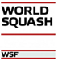

ARDIC Egyptian Junior Open 2020

ACCOMMODATION DETAILS

Nation _____________________________

Phone _____________________________ _____________________________
(with International code)

E-mail ___________________________________

ROOM DETAILS: 3 persons per room / Boys and girls separated.

NAME | NAME | NAME
 |  |  | 1
 |  |  | 2
 |  |  | 3
 |  |  | 4
 |  |  | 5
 |  |  | 6
 |  |  | 7
 |  |  | 8
 |  |  | 9
 |  |  | 10
 |  |  | 11
 |  |  | 12

Please return this form by Sunday, 21th of June 2020 00:00am

email: safa@noletegypt.com

You will find this form available as a Word Document on

http://egyptianjunioropensquash.com/

